**Problem statement**

Floods are classified as one of the most damaging natural disasters, bringing devastation and destruction in the aftermath. Case in point, the 2024 floods in Bangladesh (Al Jazeera, 2024; CNN, 2024)—afflicted an estimated 5 million people, forcing thousands to be forced from their homes, and many lives lost. These disasters are getting more frequent and intense, making the need for a revolution in disaster response systems more urgent than ever. Although (Unmanned Aerial Vehicles) have proven helpful in times of crisis (e.g., medical deliveries and public area monitoring during the COVID-19 pandemic (Avion Aerospace, 2020; Gavi, 2021)—their potential for saving lives during floods remains underutilized.

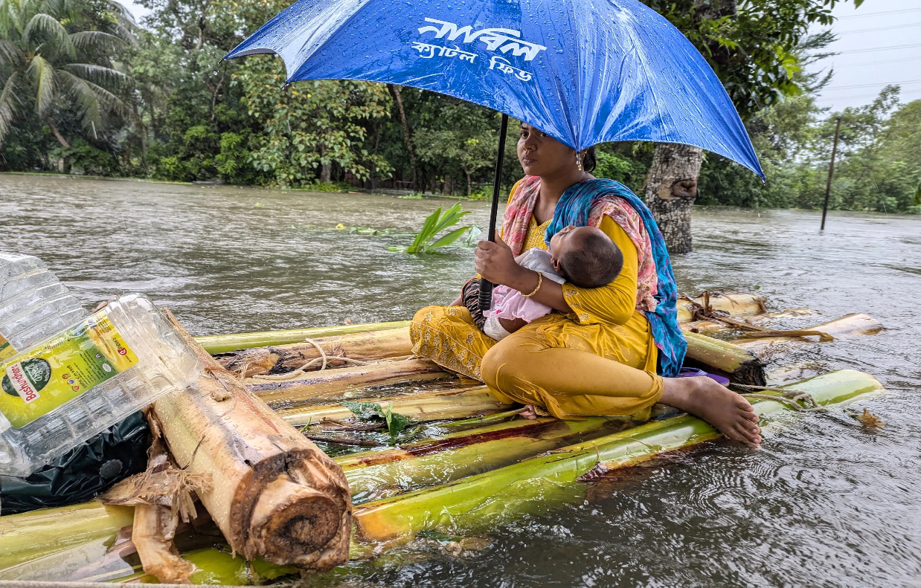

A woman and her child wade through floodwaters in Feni, one of the worst-hit areas. [Zakir Hossain Chowdhury/AFP]( Al Jazeera, 2024)

Dipta Banik from Chauddagram, Bangladesh, is one such person whose story reflects the immediate and tangible hardships experienced during such calamities. In August 2024, Dipta, and a team of specialists found a family stranded on top of a two-story building,  isolated for two days without food or a means of communicating. All the family could do was watch in despair as floodwaters tore apart their home and isolated them from help. With water depths ranging from 10–12 feet and little mobile connectivity, the situation was grave. These anecdotes of isolation and helplessness in floods are only too commonly heard and underline the urgent need for better disaster management technologies.

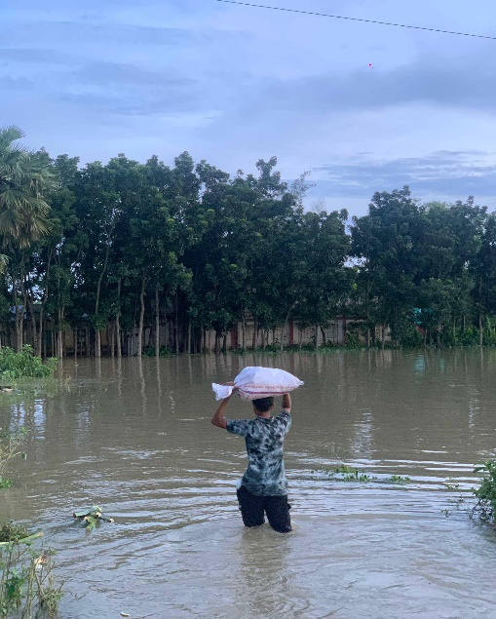

They are trying to give relief in this harsh situation. [Daipto Banik]

While the technologies show great advancement in UAVs overall, disaster scenarios present massive challenges in their application. This covers the ability to plan safe paths in intricate and inundated landscapes, maintain adaptability given varying ecological circumstances, and process current information in decisions (Bai et al., 2021). Existing methods for flood response, such as GIS-based flood mapping, depend on static topographical data that cannot adapt to real-time changes. Though useful, remote sensing technologies like satellite imaging and LIDAR are expensive, resource-intensive, and often too slow to provide immediate help during emergencies (Dhaka Tribune, 2013).

To address these limitations, a comprehensive system that leverages the strengths of UAVs is critical. Such a system must integrate advanced flood detection algorithms, real-time mapping, and efficient resource delivery mechanisms. By combining these capabilities with AI-powered frameworks, disaster management efforts can be transformed to save lives, reach isolated victims, and ensure faster and more effective responses in the face of increasing flood disasters.

**Related Study**

Techniques like reinforcement learning and graph-based algorithms have shown promise but often fail in real-time applications due to computational overheads and environmental unpredictability (Zhou et al., 2022). UAVs have been extensively used for real-time flood mapping and monitoring. For instance, research by Smith et al. (2021) demonstrated how UAVs equipped with LiDAR sensors could accurately map flood-affected areas, improving situational awareness for rescue teams. A study by Gupta et al. (2022) highlighted the effectiveness of multi-rotor UAVs in carrying lightweight supplies during emergencies. Thermal imaging and machine learning algorithms have been employed for detecting stranded individuals. Johnson et al. (2020) showed that UAVs using infrared cameras and AI-based image processing could identify victims with high accuracy. Despite this, it has a gap that UAVs typically have restricted payload capacities, which limits their ability to carry significant amounts of supplies or rescue equipment (Brown et al., 2023). Current UAVs often have limited flight durations, making them less effective in covering large flood-affected areas (Chen et al., 2021). Efficient coordination among multiple UAVs and rescue teams remains a challenge, particularly in areas where communication infrastructure is damaged (Lee et al., 2022). UAV performance in adverse weather conditions, such as strong winds and heavy rain, is still a limiting factor (Zhao et al., 2020).

**Research Objectives**

1. What is the purpose of this research?

Ans: This research aims to revolutionize flood disaster management by developing a cutting-edge system that leverages the power of UAVs. The project seeks to significantly improve the accuracy of flood detection, streamline rescue operations, and enhance the efficiency of resource delivery during this critical event.

2. What is the central objective of this study?

Ans: The primary goal is to create an integrated UAV-based system that utilizes advanced algorithms to achieve superior flood detection capabilities, optimize search and rescue efforts, and empower real-time decision-making during disaster occurrences.

3. How does this study differ from prior research?

Ans: Unlike previous research that heavily relied on resource-intensive tools like satellite imagery, this study focuses on a more agile and cost-effective approach by integrating UAV technology with state-of-the-art machine learning models. This approach prioritizes real-time data processing, scalability, and adaptability to improve disaster management efficiency.

4. Why is UAV technology integral to this research?

Ans: UAV technology plays a pivotal role in this research due to its unique advantages. UAVs can collect high-resolution data in real time, adapt to challenging terrains, and perform critical tasks such as rapid flood mapping and identifying individuals in need, making them indispensable for effective disaster management.

5. What methodologies will this research utilize?

Ans: This research will employ a multi-faceted approach, incorporating advanced image-processing techniques, utilizing semantic segmentation for precise flood mapping, developing efficient path-planning algorithms for optimal UAV navigation, and leveraging AI-driven frameworks to support real-time data analysis and informed decision-making.

6. How will this research enhance disaster response?

Ans: By implementing this advanced UAV-based system, this research will enable more accurate flood mapping, faster identification of individuals in need, and more efficient distribution of resources. This will address the limitations of traditional disaster management methods, leading to significantly improved response times and outcomes.

7. What specific problems does this study aim to solve?

Ans: This study aims to address several critical challenges in current flood management systems, including delayed disaster response, high reliance on expensive technologies, and a lack of real-time adaptability to evolving situations.

8. Why is real-time data integration essential for disaster management?

Ans: Real-time data integration is crucial for effective disaster management as it ensures that timely and accurate information is readily available for rescue operations and resource allocation. 1 This enables swift and informed decision-making, significantly improving the overall effectiveness of disaster response strategies. 

**Research Contribution**

This research focuses on advancing flood disaster management by addressing critical gaps in flood detection, rescue operations, and resource delivery. Traditional approaches, such as GIS-based flood mapping and remote sensing technologies, though effective, often require significant resources and lack real-time adaptability. This study proposes a unified UAV-based system designed specifically for flood scenarios, utilizing high-resolution imagery and advanced deep learning models like Compact Convolutional Transformers (CCT) and CNN architectures.

The proposed system enhances flood response by enabling real-time flood zone classification, human detection, and infrastructure assessment. It eliminates reliance on costly and resource-intensive technologies while addressing operational challenges such as collision-free navigation in flooded areas, adaptability to diverse terrains, and real-time data integration. Semantic segmentation techniques allow for detailed pixel-level mapping of flood zones, aiding in more precise rescue operations and resource delivery. This research provides a transformative and scalable solution for regions frequently impacted by severe flooding, offering timely and effective responses to mitigate disaster impacts.

**References**

1. Al Jazeera. (2024). *More than 300,000 Bangladeshis in emergency shelters after floods*. Retrieved from [https://www.aljazeera.com](https://www.aljazeera.com/).
2. Avion Aerospace. (2020). *Public monitoring by AI drone in Bangladesh during COVID-19*. Retrieved from [https://www.facebook.com](https://www.facebook.com/).
3. Bai, J., Wang, Y., & Li, M. (2021). UAV Path Planning Based on Improved A∗ and DWA Algorithms. *International Journal of Aerospace Engineering, 2021*, 1–13.
4. CNN. (2024). *Video of rescue missions in Bangladesh floods*. Retrieved from [https://edition.cnn.com](https://edition.cnn.com/).
5. Dhaka Tribune. (2013). *Rana Plaza collapse*. Retrieved from [https://www.dhakatribune.com](https://www.dhakatribune.com/).
6. Gavi. (2021). *Drone-delivered COVID-19 vaccines take air*. Retrieved from [https://www.gavi.org](https://www.gavi.org/).
7. Gebrehiwot, A., et al. (2020). Flood Mapping Using UAVs. *Remote Sensing Technologies Journal*.
8. Hassani, A., et al. (2021). Compact Convolutional Transformers (CCT) for Image Classification. *Neural Processing Letters*.
9. Hernández, J., et al. (2021). Semantic Segmentation for Flood Mapping. *Journal of Image Processing, 33*(4), 112-124.
10. Khan, M., et al. (2021). UAV-Based Flood Detection Using Deep Learning Models. *Natural Disasters Technology Review*.
11. Lygouras, E., et al. (2019). Human Detection in SAR Operations Using UAVs and YOLO Architecture. *Aerospace Research Journal*.
12. Munawar, S., et al. (2020). CNN-Based Flood Zone Classification Using UAV Imagery. *Disaster Analytics Quarterly, 29*(2), 55-72.
13. Rizk, Y., et al. (2019). Flood Detection Using VGG-16. *International Journal of Disaster Management*.
14. Roy, A., et al. (2021). Hybrid CNN and Transformer Models for Flood Mapping. *Journal of Artificial Intelligence in Environmental Research*.